# Promax Decision Support System

Project Documentation Submitted

To the Faculty of School of

Computing and Information Technologies

Of

Asia Pacific College

In Partial Fulfillment of the Requirements for the subject

Software Development

By

John Lloyd B. Briones

Rolando Aurelio Talag

Denzel Oribiana

Victor Manuel Serrano

**Table of Contents**

**Business Analytic Decision Support Systems for Realty Management** **1**

**Abstract 3**

**I. Introduction 4**

1.1 Background of the Problem **4**

1.2 Statement of the Problem **4**

1.3 Objectives **5**

1.4 Significance of the study **6**

**II. Scope and Limitations** **7**

**III. Review of Related Literature** **8**

3.1 Related Studies **8**

3.2 Related Systems **10**

**IV. Technical Background** **12**

**V. Design and Methodology** **12**

**VI. Results and Discussions 12**

**VII. Conclusions and Recommendations** **1**8

**VII. Appendices 19**

**Abstract**

As modern technology and its uses continue to grow in this fast-paced and changing world, there has arisen a need to follow the trends in order to cope with the constant changes of the environment. The use of computerized systems in the workplace has increased due to their ease of use and the benefits that they offer to the workplace. Computerized systems bring various benefits such as improved data management, real-time updates, and data security. With these benefits the various issues caused by paper-based systems can be solved and amended.

This paper presents the creation of a Payment Tracking System for the use of the development team’s client Promax Realty Corp. The payment system was made to replace the company’s current paper-based system by automating their current business process. The payment system will also be integrated with a decision support system to supplement the system’s functions. The data contained in the payment system will be used to determine the Decision Support System’s use and functions. The DSS will be presented through the dashboard which will display the information for the system’s ease of use.

1. **Introduction**

## 1.1 Background of the Problem

Nowadays, system management technologies are changing to more automated system design, which are leaning towards the use of Artificial Intelligence(AI) technology that allow machines to perceive their operating environment and take actions that ensures the maximization of the success of a goal. AI aims to perform these tasks allowing the systems that use them to perform their functions while leaving interactions to the system completely to the machine.

There are multiple ways to make use of AI technology in the business scheme. One of such applications is Decision Support Systems (DSS). Decision Support Systems are used to serve the management, operations and planning of a business or organization, resulting in the improvement of decisions in the organization. The functions of a DSS allow the provision of information for the decision makers of an organization. Realty Management can thus be enhanced through DSS application in their clientele selection, rental fees, contracts and data analysis. The key to a successful growth is the creation of a system with the function of providing relevant information on a real-time scale to decision-makers of a business. The critical factor to report automation is the ability to detect record, calculate, and finally inform all entities regarding business-sensitive data. Management of the data is also a critical factor in order to make use of the data to make sound business decisions. The need to locate, update, and modify data is thus deemed important in the business scheme, and to realize this computerized system is needed due to their data processing and data management capabilities.

## 1.2 Statement of the Problem

The client, Promax Realty Corporation (PRC) has recognized the need for the use of computerized systems in their organization. Currently PRC is in use of a paper-based system in their organization. The problem with this is that PRC is prone to data loss, data redundancy, inconsistencies in their company’s workflow. This decreases work efficiency and is thus obsolete in the current times.

As a means to address these issues the development of Payment Systems that keep track of company transactions, management of client details such as personal information, remaining balances, due dates, etc. that in turn will increase work efficiency and overall productivity. But as a payment system alone is not enough for the world's current standards a DSS that can generate reports, or analyze business data that will further improve the payment systems functions that will allow PRC to match the current standards of the market in their organization.

The research would like to answer the question.

1. What process in realty management can you apply DSS
2. How does DSS improve Realty Management services?

## 1.3 Objectives

General Objective

The team aims to improve the client company's current business system through the development of a computerized system that will replace the paper-based system. The System would increase the efficiency and effectiveness in the company’s workflow through the improvement of a payment system integrated with Decision Support functionalities.

Specific Objectives

* To develop a payment module that would track and report payments of the tenants of the company.
* To create a data entry module that would store the information of each tenants for every properties of the company.
* To develop a report generation module that would print reports and receipts of the company’s transactions.
* To design a business analytics module that would show reports,charts and statistical data that can be used to improve the decision making process of the company.

**1.4 Significance of the Study**

The result of this study will be beneficial to the following:

● To the Client

This project was initiated and established in order to create a working system for the Promax Realty Corporation. It will serve to benefit the company’s future by improving and enhancing business transactions, ease the current workflow of the business and better clientele selection. The project will help make the job of the client easier by making the system computerized, thus reducing human errors.

● To the Tenants

This project will benefit the current tenants of Promax Realty Corporation. This will help their current business relationship as the project will provide the tenants a faster and easier way to perform applications to the company as well as to be notified or updated on their current rental balance.

● To the Future Researchers

As the current means of performing business transactions are constantly evolving, this research can serve to benefit the future developments of decision support systems or other similar researches that may be undertaken by future researchers. This study could be a reference or basis for other researchers who would want to conduct a similar study.

# II. Scope and Limitations

The system consists of four different modules namely the payment module, the data entry module, the report generation module and the dashboard module.The payment module consists of payment information of the client that includes billing,payment history, and invoices. The data entry module consists of contracts,tenant information, and company information. The report generation module is used to print and generate the reports of the company.The business analytics module contains all the reports that the client needs such as property earnings, contracts status, available units,income chart and the recently added tenants.The data sets used in this project follows the format that Promax Realty Corporation uses in their day-to-day operations.

The Project is designed only for the use of the project owner and their authorized users of promax realty corporation. Tenants will have no interaction with the system apart from their interactions with PRC staff.

# III. Review of Related Literature

## 3.1 Related Studies

**Payment Systems in Malaysia: Recent Developments and Issues**

The article states that Payment systems in Malaysia and in some other countries have been undergoing changes in recent years. Among those changes is the emergence of electronic-based payment systems. The central bank has been playing an active role in shaping the development of payment systems, particularly in the gradual introduction of electronic-based payment schemes. It is believed that by using payment systems the potential to increase efficiency in the economy as whole and each small businesses and firms individually. The payment instruments have increased both the value and volume of transactions per capita use of e-payment instruments in recent years. Small- and medium-sized enterprises could benefit tremendously from the use of e-payment schemes through more efficient business operations, cost reductions, enhanced security, and wider payment channel choices. The article states that small firms and businesses such as Promax Realty Corporation could benefit from payment system.

Amir Akmar Basir (2009) *ADBI Working Paper Series.Payment Systems in Malaysia: Recent Development and issues* no. 151 1-2. Retrieved from https://www.adb.org/sites/default/files/publication/156006/adbi-wp151.pdf

**Core Principles for Systematically Important Payment Systems**

Safe and efficient payment systems are critical to the effective functioning of the financial system, payment systems are the means by which funds are transferred among banks, and the most significant payment systems are a major channel by which stocks can be transmitted across other financial systems and markets. Payment systems are therefore a key requirement in maintaining and promoting financial stability according to the article. Also, the article states that it is intended for use as universal guidelines to encourage the design and operation of safer and more efficient systematically important payment systems worldwide. The payment system proposed to the client is efficient and effective. This article will help on giving the team some ideas on how to make an effective and efficient design for the payment system.

(2001) *Core Principles for Systematically Important Payment Systems Retrieved* from http://www.bis.org/cpmi/publ/d43.htm

**Transaction Plan: Consolidating Payment Systems for Improved Efficiency, Security and Usability**

Payment processing has grown ever more complex and the popularity of electronic payment has grown significantly. The number of payment points on campus for colleges and universities has added new payment systems to support electronic transactions for tuition and student fees, housing, parking, bookstore and other campus services. The result has been a patchwork of disconnected systems accompanied by redundancies, inefficiencies, unnecessary costs and security headaches. Colleges and universities can solve many of these problems by stepping back and looking at the big picture of campus transactions. By consolidating multiple payment sloes into a single, unified system for the entire campus that is integrated with the enterprise resource planning (ERP) system, they can save time and money while improving security and user experiences for both students and administrative staff. The article was somehow related to the team’s project because just like the company of the client, the payment for their business has grown just like in colleges and universities like what the article mentioned, so the company needs to upgrade and let go the old system which is being paper based. But before that can happen, the team needed to picture what their client wants for their company. The team will need a plan before they can produce an effective and efficient working payment system.

(2014) *Transaction Plan: Consolidating Payment Systems for Improved Efficiency, Security and Usability* Retrieved from https://www.touchnet.com/prod/pdf/Consolidating_Payment_Systems_final.pdf

#### Method and apparatus for tracking multiple payment resources and charging transactions to payment resources in on line transaction processing system

The patent focuses on the payment and transactional functions of a system. The research shows a usable method of accounting the payments. The patent stores transaction information into a database and promptly manages the obtained information into their respective data repositories. The payment methods within this patent can serve as a reference to the methods applied into the project system. Application of such methods into the system requires further study.

(2000) *Method and apparatus for tracking multiple payment resources and charging transactions to payment resources in on line transaction processing system.*Retrieved from https://www.google.com/patents/US6047267

#### Application of Decision Support Systems and Its Impact on Human Resources Output: A Study of Selected Universities in Zimbabwe

This is a study that focuses on the use of decision support systems and its effect on human output. The paper initially defines the necessary scope that encompasses the workings of a decision support systems and literature related to the human factor. The Research shows key points that are the Decision Support System (DSS), hardware and software requirements, networking, data analysis, human output. Necessary data were collected from various respondents that are from the managerial positions in a Zimbabwean university with proper knowledge on the inner workings of their organization. The conclusion of this study states that DSSs enhance decision making to a greater extent but is still debated on by various scholars if DSSs potentially remove the human element from the decision making process. The study requests to be performed on various other economical sectors (such as the financial sector) in order to create a definitive theory on the influences of DSSs on Human Output.

(2013) *Journal of Computer Sciences and Applications*, 1 (3), pp 46-54. DOI: 10.12691/jcsa-1-3-4

## 3.2 Related Systems

**ONB Oesterreichische National Bank Euro System**

Payment systems according to the site represent an important component of the financial market infrastructure. They provide financial intermediaries – the economic agents of the financial system – with liquidity and ensure that liquidity flows smoothly between the public sector and households. Payment systems operate on the principle of stability and security as well as the guarantee of fast and cost-efficient transfers. The special feature of such payment systems is that they handle euro transactions in real time and with settlement finality. This is related to what the team wants for the system to do. The team wants the system to be real time, stable and fast so that when a client needs to check or verify something regarding their payment, it is easily located by using the payment system. Thus, it is not time consuming and it will be both convenient for the client and user of the system.

# *Oesterreichische Nationalbank* Retrievedfrom https://www.linkedin.com/company/oesterreichische-nationalbank

**Payment Systems of the Philippines**

The central bank, Bangko Sentral ng Pilipinas (BSP), previously handled inter-bank wholesale funds payments using a proprietary RTGS-based system or MIPS2 Plus. The improvement of customers’ account depends upon the upgrading of payment infrastructures by individual financial institutions rather than on the further development of payment systems by the financial authorities. Nonetheless, such improvement is vital for the enhancement and efficiency of wholesale funds payment systems in the Philippines. In order for the team to create an effective and efficient payment system, the team needs to research on possible basis for their concept and design. There are some available payment systems out there that the team can use, just like the banks mentioned in the article. Some banks have different based systems. It depends on what they think is working best for them. For the team to know which payment system they can use for their basis of the project, a further study and research is needed.

#### Payment Systems of The Philippines. Chapter 7 p.79-80. Retrieved from http://www.academia.edu/6581070/Chapter_7_Payment_Systems_of_The_Philippines

**WebFOCUS (by Information Builders)**

Managing and administration are the key to create a successful system anyhow the said system above contains a lot of features in that could improve the efficiency and effectiveness of the system such as reporting, analysis, distribution, personalization, development and lastly, management and administration. Mostly these are the things that the team wants for the system to do. Thus, it is accessible and uncomplicated for the users so that it could help the users to increase their productivity.

*The Key to Optimal Systems Performance and Secure Wide-Scale Distribution.* Retrieved from <http://www.informationbuilders.com/products/webfocus/manage_admin>

# IV. Technical Background

The system is an application makes use of the ERP framework. The system uses a customized ERP payment function which is reflected in the systems payment module. ERP was used due to their efficiency in managing data in real-time, its ability to generate reports when needed and its ability to collate all data. The system was built using Laravel. Laravel is a free and open source PHP web framework that develops web applications using the Model-View-Controller (MVC) Pattern. With the laravel framework designing the system was eased due to their built-in templates as well as the Artisan functions which allows manipulation of laravel through a command line and decreases the need to type code repetitively. This system uses the Apache Web server through the XAMPP control panel due to its high compatibility with various Operating systems at no cost; the system database uses MySQL due to its ease of use and its compatibility to any operating system

# V. Design and Methodology

**Agile Methodology**

This is the methodology used in the development of the proposed system. The project team performed the tasks of the project through a repetitive cycle called iterations or sprints. The use of the agile methodology guarantees the quality of the proposed system through the development lifecycle. The team went through various iterations of the process starting from analyzing, designing, developing and testing of the systems functions in order to develop a quality assured system. Each iteration is performed from start to finish with analyzing as the start and testing as the finish. The system is expected to go through 2 iterations during the process.

**VI. Results and Discussion**

**Planning and Data Collection**

The initial stages of the project were spent on planning out the process on how the team will perform the project as well as gathering the necessary data and information. Data gathering will be performed through periodic meeting with the client thru an interview in order to get an idea on the specifications and requirements that they need from the project. These meetings will also be used in order to obtaining necessary information such as the sample datasets that the company uses in their operations, Business processes and practices that the company currently uses, and plans for improvement that the company may have. These meetings also serve the purpose of determining the objectives the team would like to accomplish for this project. These meetings served as the communication of the team with the client. Meetings are held if the team need some certain information or whenever the client thought of some features or functions that they want us to developed and to put in the system.

## Research and Design

After Data collection, diagramming the processes provided by the company and the transactions they had will be done in order to obtain a clearer picture on the company’s processes and daily operations. Upon finishing the diagrams, the team can decide where to improve it in order to implement the computerized system. After diagramming the processes the team will start to research on the usable tools and software that can be used to meet the project requirements.The team will research on other functions that the company might need as well. The team will also research on the best design that would suit best to the system. Also research on the applications of Decision support systems and on what ways it can be applied on a realty corporation will be done as well.

## Development

After data gathering, researching and conceptualizing the design, the team started to develop the system. The prototype of the proposed system used the Laravel framework for the creation of the system design. The system also used the ERP framework as the basis for its payment system functions. The web server XAMPP was also used as it was necessary for the system since it required access to a localhost server while using the Apache and MySQL modules. The system was run and tested using google chrome, but other browsers can be used to access the project.

PhpMyAdmin which can be accessed through XAMPP was used for the systems database. All data required for the systems functions such as the payment system and dashboard will be obtained from here.

Data used for the system will be dummy values that use a similar formatting to the one used by the company. This data set will be obtained from the company through the projects data collection.

The project implemented the use of a customized ERP system in the proposed system in order to utilize its various functions and to standardize the system. With the use of the erp framework work has been cut substantially due to the team only being required to manage the company’s datasets and modifying the system in such a way that the framework is personalized for the use of promax realty corporation. The Payment module, report generation module and data entry module are the parts where the erp framework is implemented

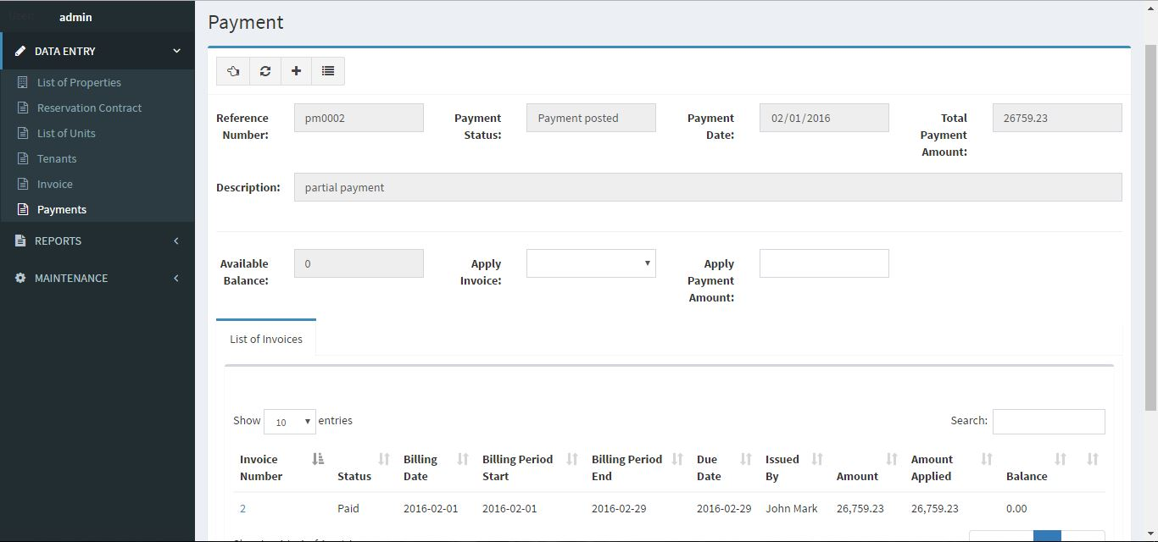

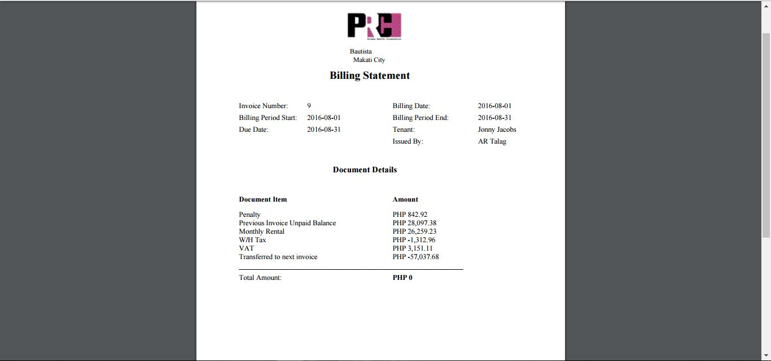

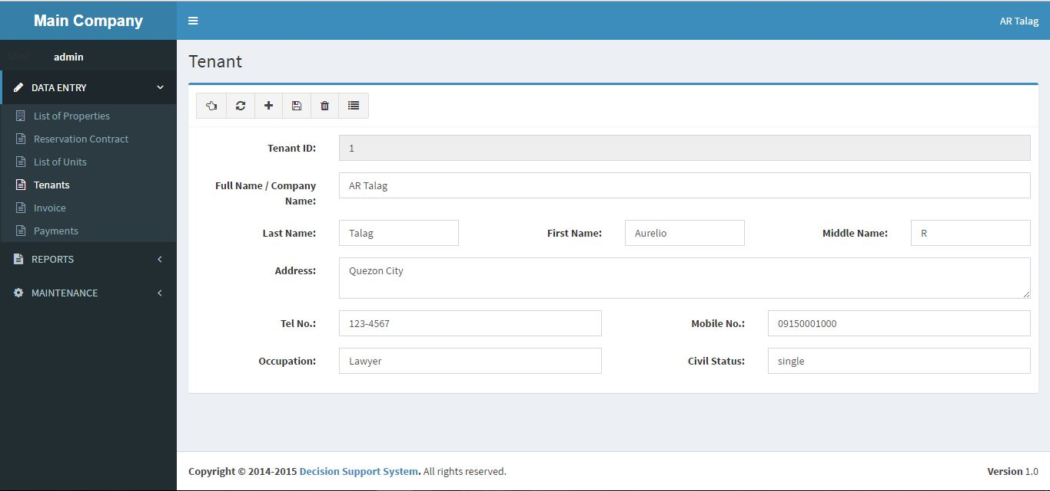

As the main focus of the project the Dashboard has multiple components that together function as a whole to generate accurate reports on key parts of the business.

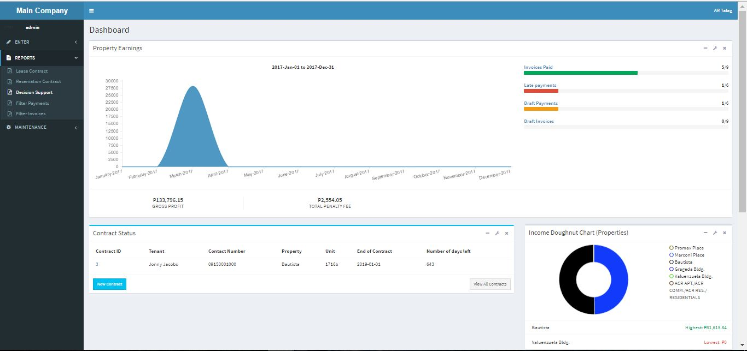

One is the property earnings table which displays the projected earnings of each property depending on the date range that is currently used. This is used for determining what are the earnings of each property at any given time.

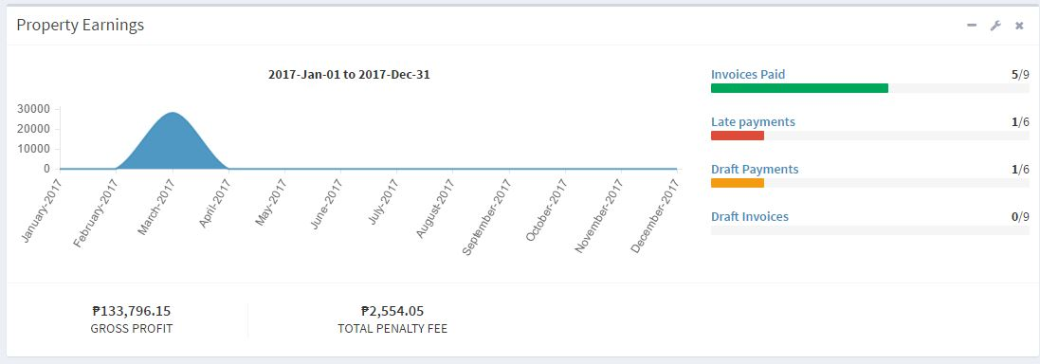

Next is the contract status table which displays all active and inactive contracts of promax realty corporation. This determines how the company regards their tenants.

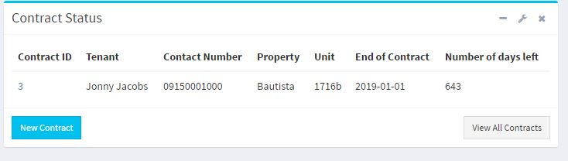

Next is the available units table which detects the current vacancies of each property in order for the company to keep an up-to-date record of what the company can offer to their prospective tenants without having to go through multiple records.

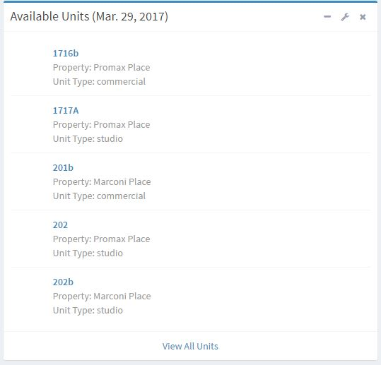

After which is income chart, a chart used to determine the total earnings of a property from the earliest inputted information to the latest. As compared to the property earnings table this chart cannot set date ranges and is meant to display a single chart for all the accumulated earnings of every property

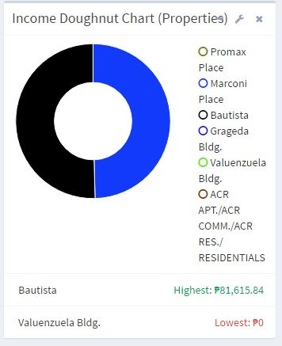

Lastly is the tenants table which displays the most recently added tenants and what properties do they occupy. This is used to keep a record of all newly acquired tenants and to monitor them die to the need to build up trust with the company.

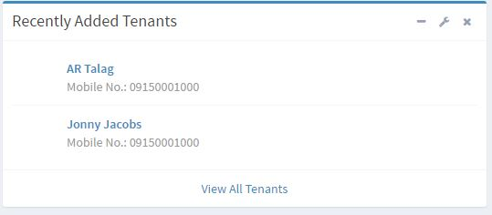

# VII. Conclusions and Recommendations

As technology continues to grow there will always be a need to innovate the currently developed systems today. This paper aimed to develop a functional payment system of the client that was further modified in order meet the standards of current designed systems. This has shown improvements and further possibilities as compared to the usual payment systems that normally only record and store data as well as making simple computations.

The Data Entry module has improved significantly the management of data and records. Accessibility to said data has also improved and allows future improvement of the business through the business analytics module. The payment module has eased the process of performing and recording transactions and gives the company access to well organize payment records. The reports generation module shows improvement through the automation of the process as compared to the initial paper-based activities which involved manual computations and report creation. The business analytics module on the other hand has shown improvements to the common standards of payment system as it collates and generates the functional reports of the system and allows the company to understand the bigger picture of the company’s status and better decision making in the project.

The team recommends further development of the decision support system functions especially in the field of predictive analysis that allows the system to generate reports that would give the client an idea of possible trends or possibilities in the company utilizing information that the company currently possesses. As such large quantities of historic data are a necessity so that the system may perform analysis on a multitude of varying forms of data.

**Appendix**

**Business Process**

The project will follow the business process that is currently used by the Promax Realty Corporation.

1. The company offers a minimum 1 year contract for all of their properties

2. The company uses 4 weeks billing periods

3. Thefirst month of the contract will be paid for in full to serve as a contract reservation fee.

4. Tenants are given 3 weeks to pay their rents. Starting from the first day of the billing period.

5. A penalty of 3% of the monthly rental will be asked for if the tenant fails to pay the monthly rental.